A
PROJECT REPORT ON
Student Attendance Management System
Submitted in partial fulfilment of the requirements for the degree of
Bachelor of Technology
In
Information Technology

By
Sakshi Sunil Patil 2254491246048
Saurabh Dinesh Patil 2254491246049
Shreya Subhash Patil 2254491246050
Anushka Diwakar Pawar 2254491246002
Varsha Hiraman Pawar 2254491246063

Under the Guidance
of
Prof. Niteen Dhutraj


DEPARTMENT OF INFORMATION TECHNOLOGY
SHRI VILE PARLE KELAVANI MANDAL'S

INSTITUTE OF TECHNOLOGY, DHULE
Survey No. 499, Plot No. 02, Behind Gurudwara, Mumbai-Agra National Highway Dhule- 424001, Maharashtra, India.

Academic Year 2024-25

INDEX

Topic Page No
Problem Statement 3
Literature survey 4
Requirement analysis 5
System analysis 6
System design 7
Implementation 8
Use cases 9
Testing 10

- Problem Statement
To develop a student attendance Management System that allows teachers. to efficiently mark and manage student attendance, edit student details and generate reports. The System aims to provide a user-friendly interface for tracking attendance records and ensure easy access to attendance summaries and analytics.

Objectives :
- Mark and manage student attendance in real time.

- Edit and update student details when needed.

- Generate reports summarizing student attendance, class statistics, and overall trends.

- Provide a user-friendly interface for easy navigation and interaction with attendance data.

- Ensure accurate record-keeping with analytics and insights for better decision-making.

- Literature Survey
A literature survey investigates the different types of attendance management systems available and their methodologies. Some common types of systems include:
Automated Attendance Systems :
Utilizing technologies biometrics, RFID, and QR codes to enhance tracking efficiency and accuracy while requiring higher initial costs and maintenance.
Mobile and Web-Based Attendance Systems :
Teachers to mark attendance using smartphones or computers, providing flexibility and real-time synchronization with cloud databases for efficient data access and management.
Student Data Management :
Attendance management systems often integrate student information systems (SIS) to allow teachers to edit student profiles and manage detailed records

Previous studies highlight the following :

Automating attendance management minimizes manual errors and cuts down administrative expenses.
Linking this system with other institutional platforms boosts its overall utility.
Ensuring data security and privacy is essential when designing the system.

- Requirement Analysis

Functional Requirements :

User login :
Secure login with username and password.
Admin : Full control over attendance and reports.
Teachers/Employees : Can mark attendance and view class reports.

Mark Attendance :
Admin: Marks attendance for all users across different groups.
Users: View personal attendance history (present, absent, late).

View Reports :
Admin: Generates daily, weekly, and monthly reports.

Edit Attendance :
Admins should be able to edit or delete attendance records if there are mistakes.

Non-Functional Requirements :

Performance:
The system should operate quickly, enabling prompt attendance marking and enforcing role-based access.

Usability:
The interface must be user-friendly, catering to those who may not be tech-sarvy.

Scalability:
The system must seamlessly handle a growing user base as the organization expands, ensuring consistent performance without degradation.

Reliability:
The system should ensure high availability and functionality with minimal downtime.
- System Analysis
Actors :
- Teacher :
Log in.
Select class.
Mark attendance.
View reports.
- System :
Process teacher and student requests.
Manage attendance data.
Generate reports.
Processes :
- Teacher Login/Authentication:
- Attendance Marking
- Student Attendance Viewing

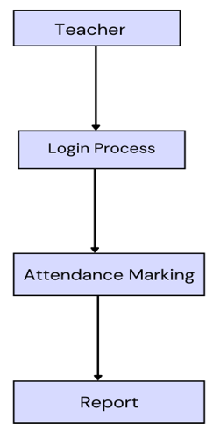

Fig 4.1 Attendance process
- System Design

ER Diagram
Entities :
Teacher (Name, Email Id, Password, Confirm Password)
Student (Name, Roll No, Email, Phone)
Attendance (Name, Date, Status, Roll No)

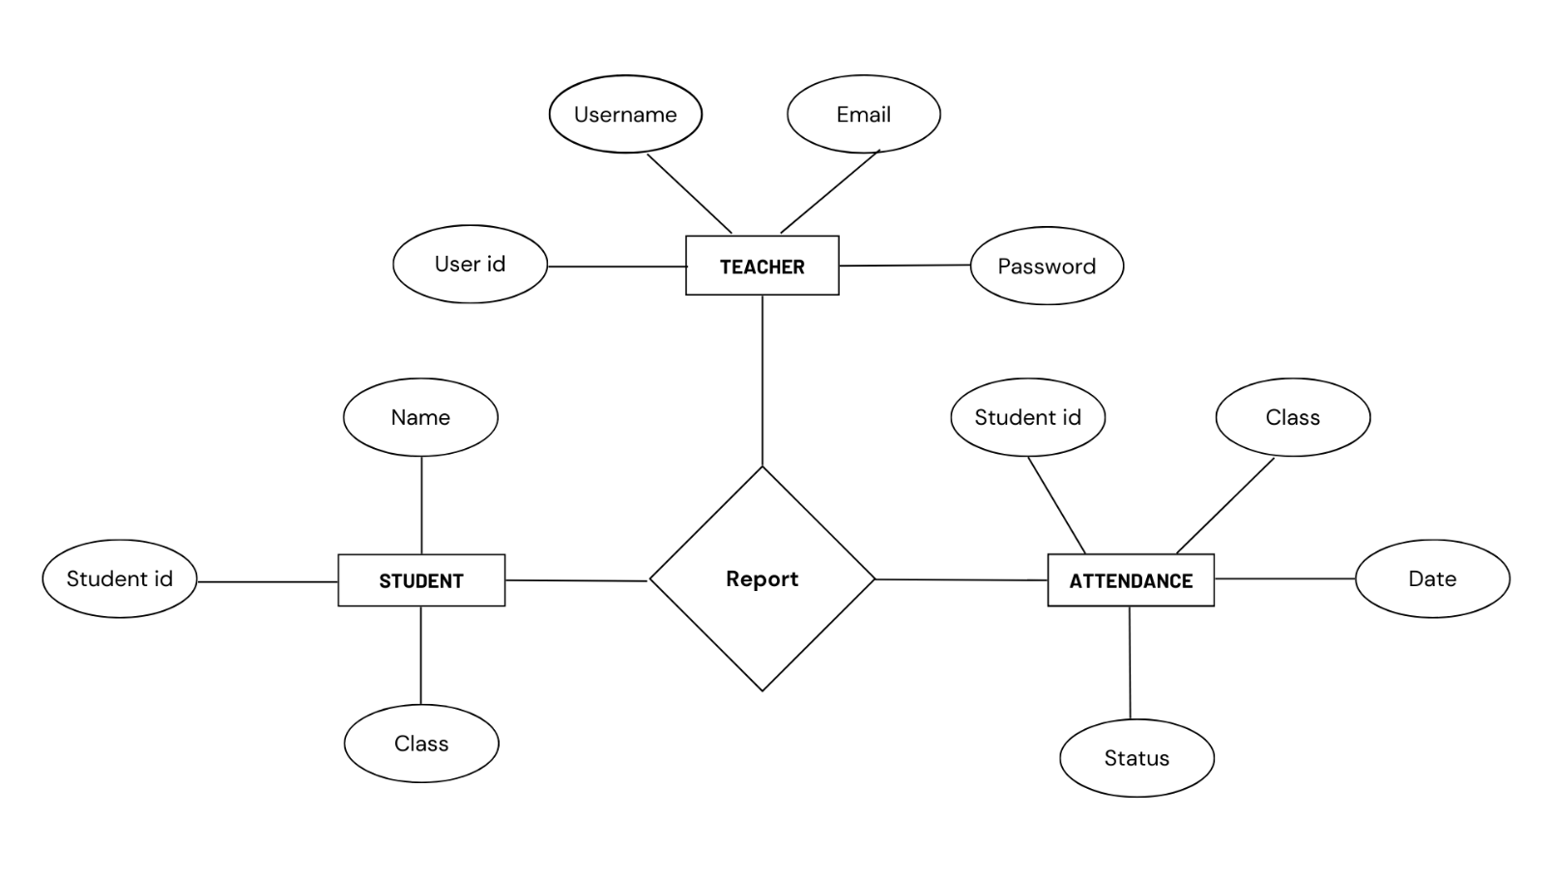

Fig 4.2 ER Diagram

- Implementation

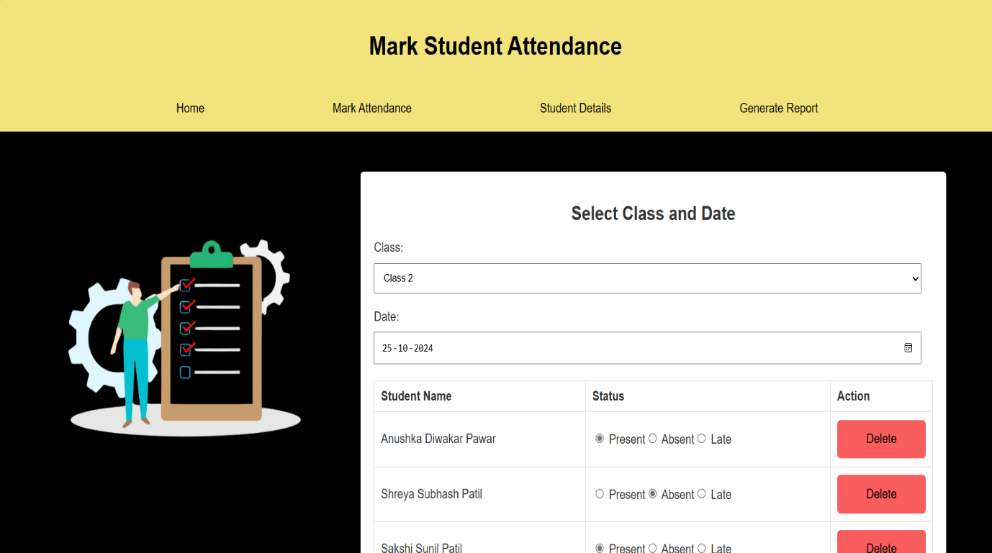

Fig. 1.3 Mark Student Attendance
The "Mark Attendance" page allows teachers to select a class, view the student list, and quickly mark each student as "Present" or "Absent" with a single click or toggle.

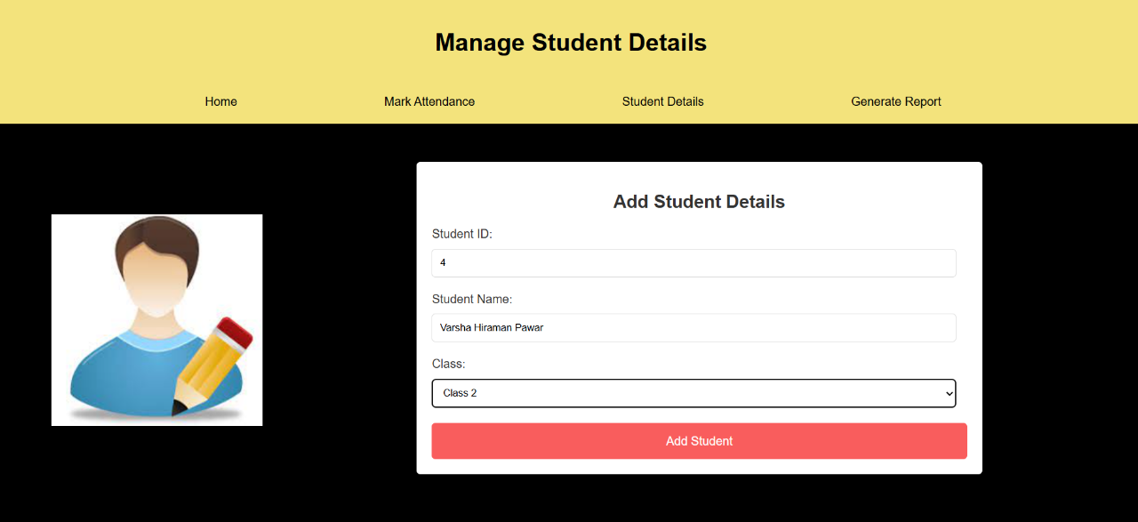

Fig. 1.3 Manage Student Details
The "Add New Student" feature enables administrators to input a new student's details, such as name, ID, class, and other relevant information.

- Use Cases

1. User Registration :
Actor : Teacher / Administrator
Flow :
- Allows new users to create an account in the system.
- Users provide personal information such as name, email, password, and role (teacher/administrator).
- The user must have a valid email address.
- A new user account is created and stored in the system database.

2. User Login :
Actor : Teacher / Administrator
Flow :

- Enables registered users to log into the system using their email and password.
- The system verifies credentials and grants access to the appropriate user interface.
- The user is logged in and redirected to their dashboard.

3. Marking Attendance
Actor: Teacher
Flow:
- Allows teachers to mark student attendance for a specific class session.
- Teachers select the class and mark students as present, absent, or tardy.
- Attendance records are updated in the system and stored for reporting.

4. Student Viewing Attendance Report
Actor: Student
Description:
- Allows students to view their own attendance reports.
- Students can access their attendance history, including total classes attended, absences, and attendance percentage over a specified period.
- The student must be registered and logged in to the system.
- The attendance report is displayed, showing the student's attendance record in a clear format.

- Testing

Unit Testing :

Test Case 1 : User Registration ( Sign up )
Successful Registration
Input : Valid name, email, password, and role.
Output : User account is created, and a success message is displayed.
Duplicate Email Registration
Input : Email already in use.
Output : Error message indicating that the email is already registered.

Test Case 2 : Login
Successful Login
Input : Valid email and password.
Output : User is logged in and redirected to the dashboard.

Test Case 3 : Invalid Login
Incorrect Password
Input : Valid email and incorrect password.
Output : Error message indicating invalid login credentials

Test Case 4 : Teacher Marks Attendance
Successful Attendance Marking
Input : Teacher selects a class and marks students as Present, Absent, or Late.
Output : Attendance records are updated successfully with a confirmation message.

Integration Testing:

  - Frontend and Backend Interaction :
Test Case : When a teacher marks attendance via the user interface (frontend), the backend should properly process the data and store it in the database.
Expected Outcome : Attendance data entered through the frontend should be accurately stored in the backend and retrievable upon request.

  - Attendance Data Retrieval :
Test Case : When a student or teacher requests attendance data (through the frontend), the system should retrieve it from the database and display it correctly.
Expected Outcome : The requested attendance records should be displayed in the frontend without any delays or errors.

